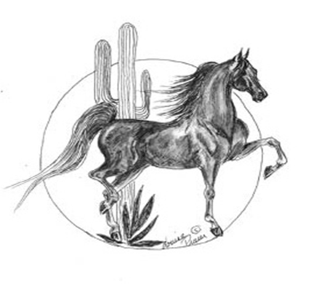
American Saddlebred Association of Arizona
29455 N. Cave Creek Rd Suite 118 #421
Cave Creek, AZ 85331

ASAA SCHOLARSHIP APPLICATION GUIDELINES

Statement of Philosophy: The purpose of the American Saddlebred Association of Arizona Scholarship program is to provide secondary academic education scholarships to members of the American Saddlebred Association of Arizona (ASAA) who demonstrate the following: involvement with and commitment to the show horse, and proven academic success. Our hope is that this program will encourage the continued participation of our members while pursuing academic opportunities after high school, along with strengthening the show horse industry and breed participation.

Scholarships will be awarded on the basis of submitted evidence of eligibility, academic success, extracurricular activities (including community service), involvement with the show horse industry.
Applicants must be a junior or senior in high school or a college student.
Scholarship awards will be paid directly to the institution, university, college or trade school for post-secondary educational expenses. If the applicant remains eligible, applications may be resubmitted annually.
Scholarships may be awarded to the same applicant more than once.
Included in the application will be a written essay outlining why they applicant is deserving of the award. Essays should be at most two (2) pages, single-spaced, and in 12-point type on the following topic, “How has your involvement in the horse industry impacted your character and who you are today?”
One letter of reference is required and may not come from ASAA board members. All references must be received directly from the author and received electronically or postmarked by April 1, 2021.
Applicants must sign and submit the downloadable document “Assignment of Rights and Consent to Publish Scholarship Information.”
Completed application, essay, reference letter, Assignment of Rights and Consent to Publish document, and a photo suitable for publication must be either received electronically or be postmarked by April 1st 2021. Electronic submissions are preferred.
Note: No applications will be held for review in subsequent years. All information submitted with the application will be held in strict confidence. No applications will be returned.

Questions should be directed to the Scholarship Program Chair, Jolene Yerckie at: jolenegalvin@yahoo.com.

All electronically submitted applications should be sent to:
jolenegalvin@yahoo.com
All postmarked applications should be sent to:
AMERICAN SADDLEBRED ASSOCIATION OF ARIZONA
ATTN: SCHOLARSHIP PROGRAM
PO BOX 27257
SCOTTSDALE, ARIZONA 85255

