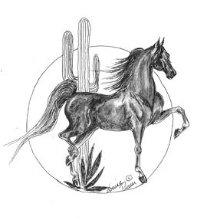

Dear

The American Saddlebred Association of Arizona (ASAA) thanks for your generous donation. Your money helps us further our mission promoting the Saddlebred breed and enriches the Saddlebred experience for our members and exhibitors at the local level.

Below is your receipt for tax purposes. ASAA is a 501c(3) non-profit corporation and your contribution is tax deductible as charitable contributions to the extent allowed by law.

If you need anything further, please let me know.

Sincerely,

Matthew Roberts
ASAA President

American Saddlebred Association of Arizona
Receipt for Donation

Tax ID: 26-4318626
Date:
Donor:
Amount:

ASAA
29455 North Cave Creek Road Suite 118 #421 Cave Creek AZ 85331

