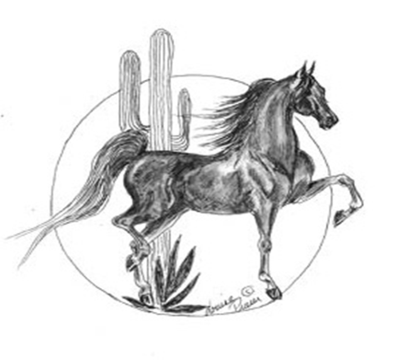
American Saddlebred Association of Arizona
PO Box 27257
Scottsdale, AZ 85255

ASAA Scholarship Application Checklist

The purpose of this checklist is to assist the applicant in the preparation of the scholarship application and to enable the ASAA Program Administrator to confirm that all required components of the application are received in the ASAA office by the April 1 deadline. If the application is not completed by the deadline, it will not be forwarded to the ASAA Scholarship Committee for review.

Please initial once you have completed the numbered requirements and return with your application. Thank you.
___1) The most current form of the scholarship application has been used.
___2) The following information must be included: name, address, telephone number, date of birth, social security number.
___3) An essay written by the applicant is included, addressing the topic listed in the Essay section of
the application.
___4) A separate list of scholastic, ASAA, and community activities is included.
___5) Applicant’s signature and date signed is completed.
___6) The name, address and phone numbers of a reference is included on the References section of the application, according to the recommended guidelines.
__7) A photo suitable for publication of the applicant is enclosed.

