American Saddlebred Association of Arizona
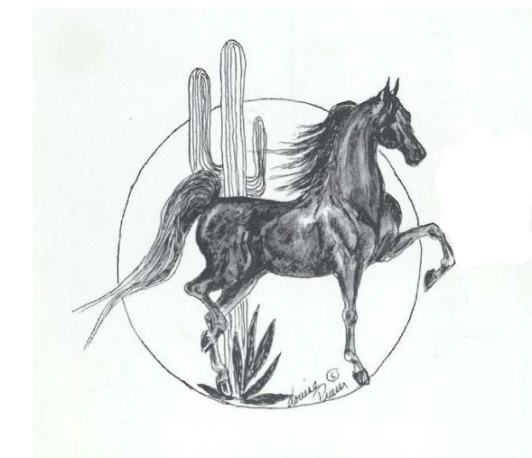
Membership Application
Join now for 2023!

Annual Dues are $30.00 per Individual

Name:
Address:
City: State: Zip:
Phone: Email:

Jr. Exhibitor: Yes No If Yes, Date of Birth:

Names of Horses Exhibiting:

Stable Name:

Donation to ASAA:
ASAA is a 501(c)3 organization and your donation may be tax deductible (check with your tax advisor)

Mail application with check to:
ASAA
29455 N Cave Creek Rd, Ste 118-421
Cave Creek, AZ 85331
Email application as an attachment with payment information to: matthew@matthewrobertsstables.com

Payment by Credit Card: Visa MasterCard Discover American Express
A 4% service fee will be added to each transaction.

Card Number:
Expiration Date: CVC Verification:
Name on Card:
Billing Address
Address:
City: State: Zip:

